Debugg Local Websphere in Eclipse

Steps followed:
- Login to websphere console . Go to server -> server types-> Websphere application servers on left pannel

- Click on servers -> Java and process Management -> Process definition
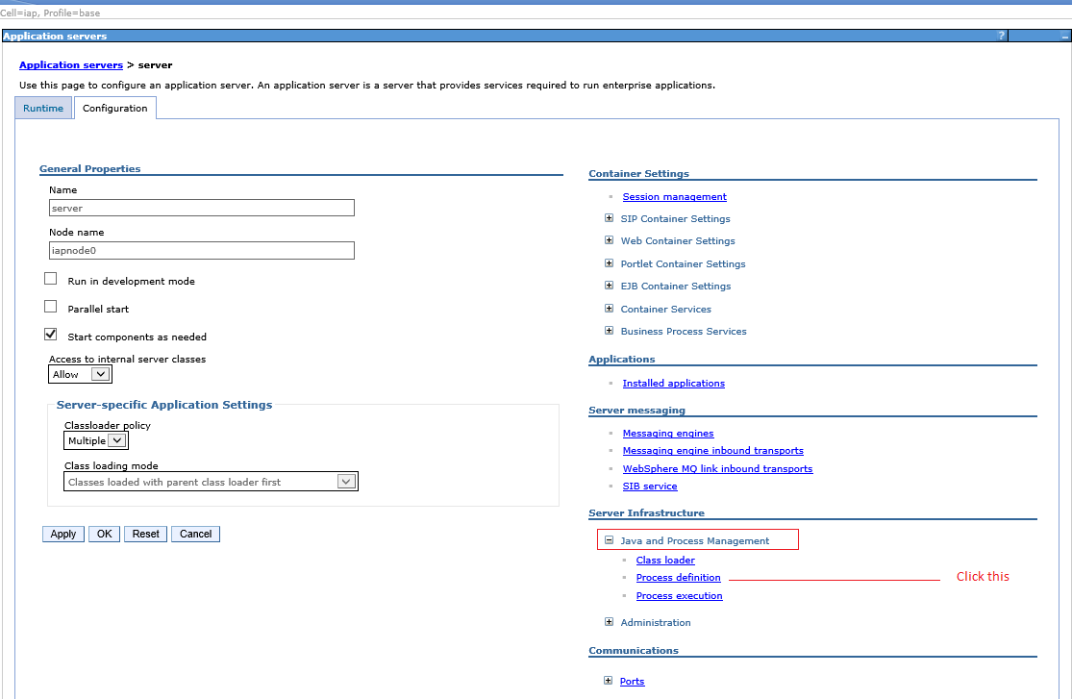

- Click -> Java Virtual Machine

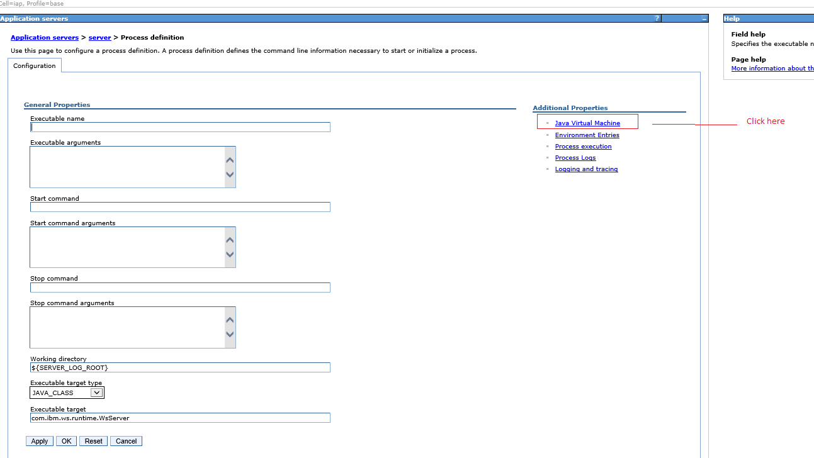

- Enable the check box “Debug Mode” and enter the debug arguments
“-Xdebug -Xnoagent -Xrunjdwp:transport=dt_socket,server=y,suspend=n,address=7777”

Apply the changes and save.

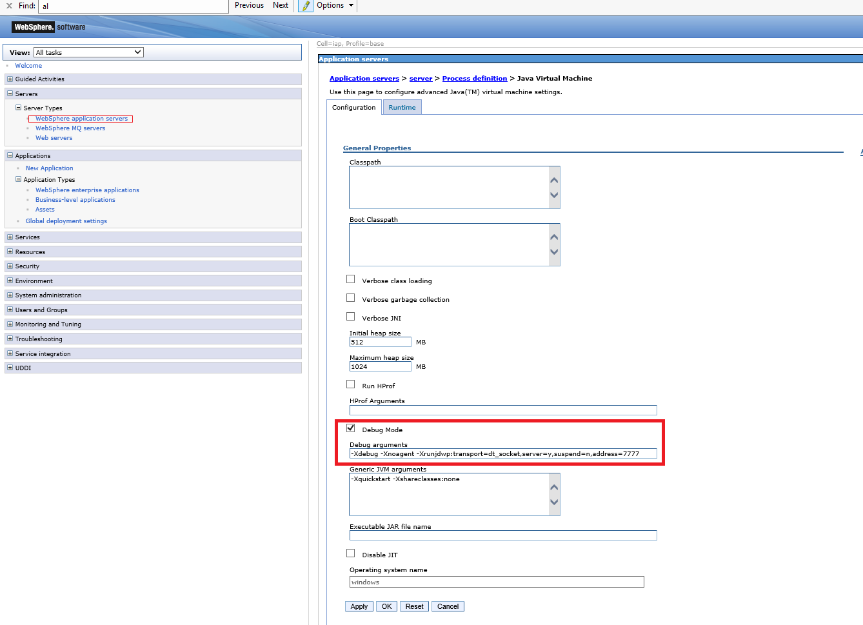

- In eclipse, right click on SOE-WAR project and debug as debug configurations.
- Restart the websphere server.
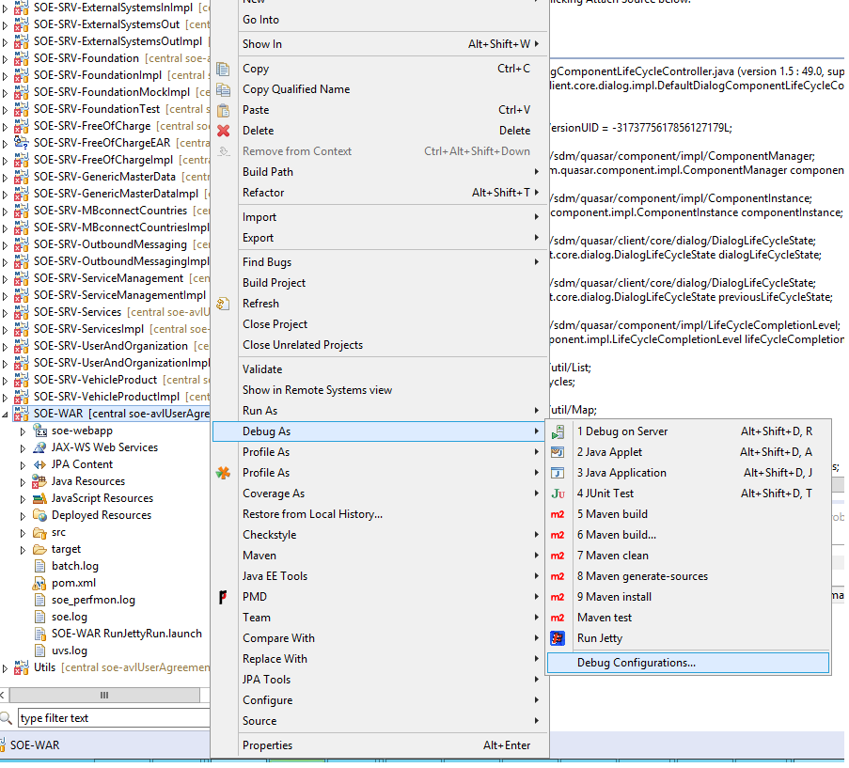

- Host : localhost
Port: 7777

Add the required break points.

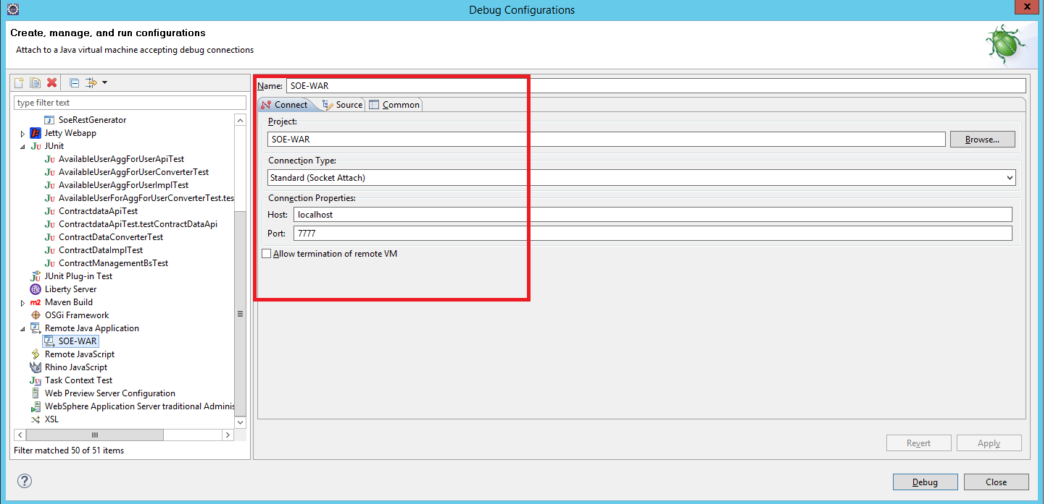
- In source tab , add the projects that you wish to debug
Click debug
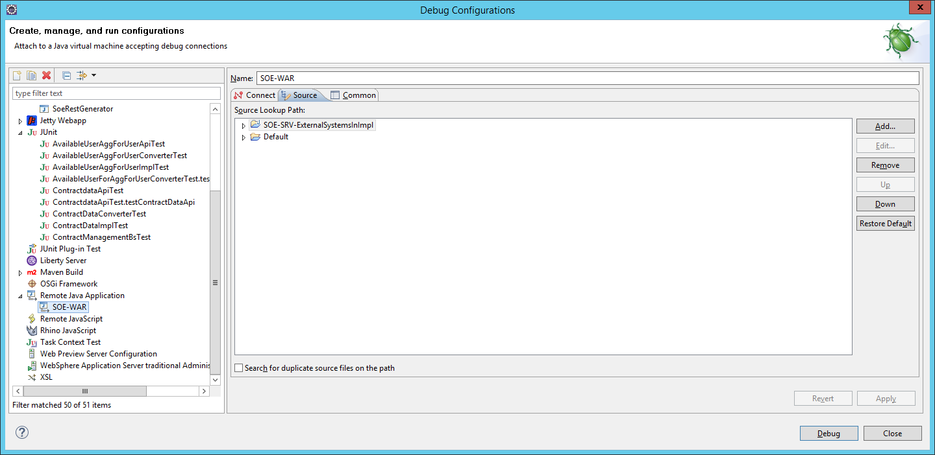
- Hit your SOE application
http://localhost/weblogin/login?webapp=/soe

